**ITMD 510 Final Project Phase I- UML installation, creation & submission**

UML design steps for Final Project

I. Installation of ObjectAid UML

To install the ObjectAid UML Explorer software plugin into Eclipse

a. Go to <http://www.objectaid.com/download>

and copy the URL towards the top right of the page under where it says **Download**.

Ex.

<http://www.objectaid.com/update/current>

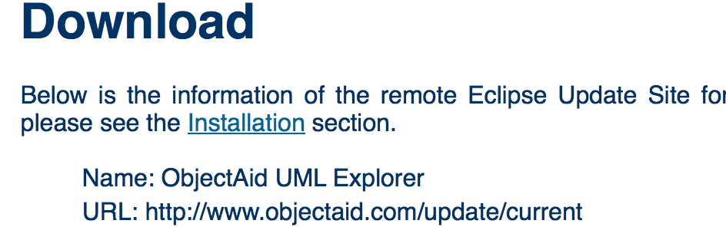

Next open Eclipse and from your menu choose Help > Install New Software…

Then in the Work with: area, 1 paste in your url. 2 Click Add and at the pop up

3 type in some name for the plugin.

1 2 3

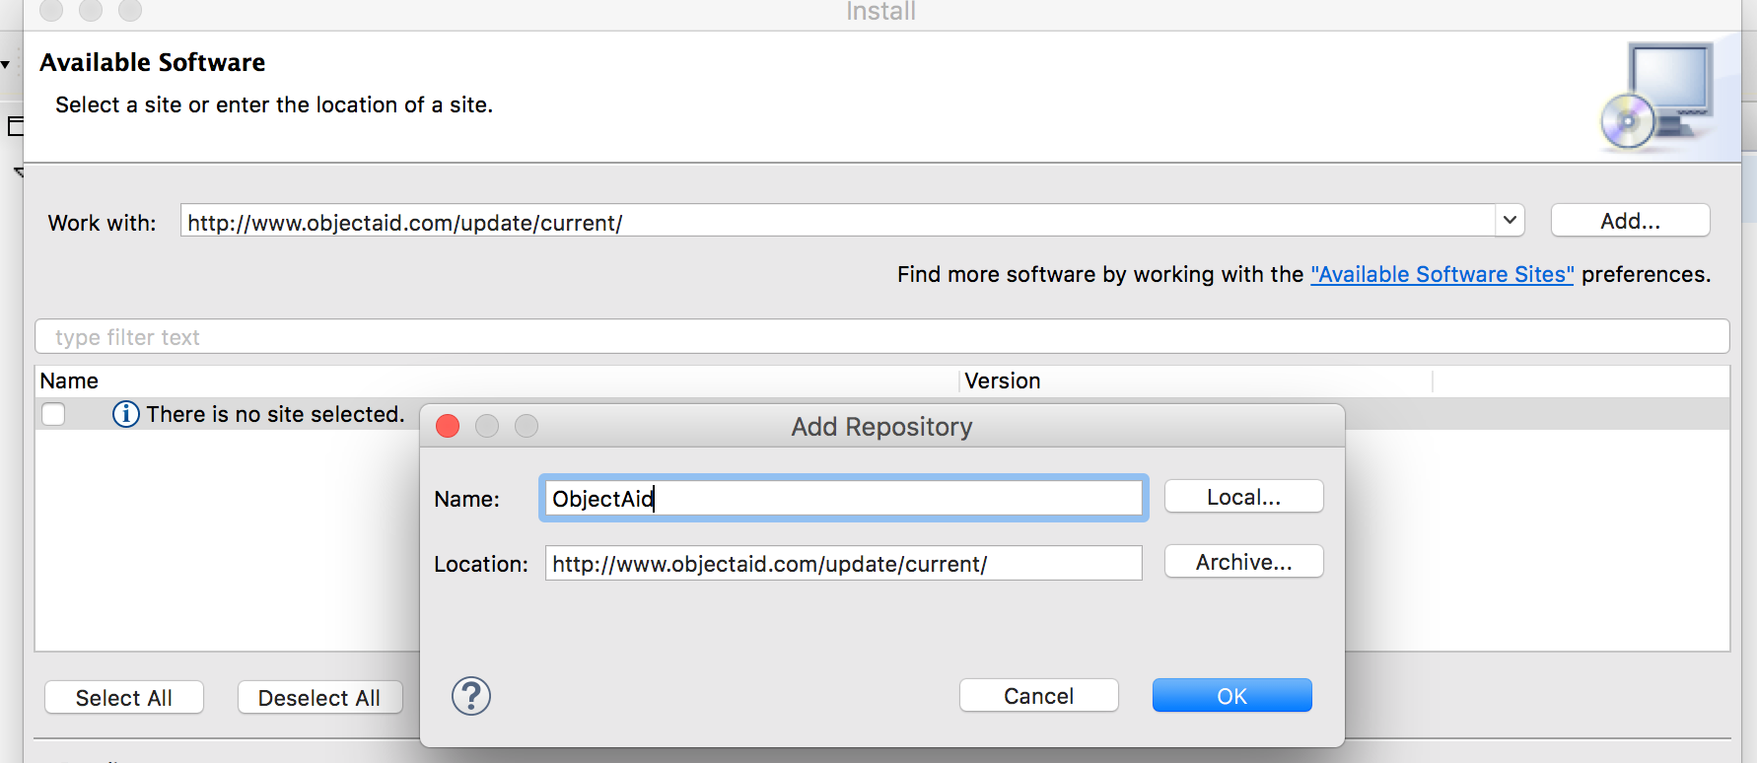

Click OK to commit your added Repo.

b. Next click on the check box as shown below.

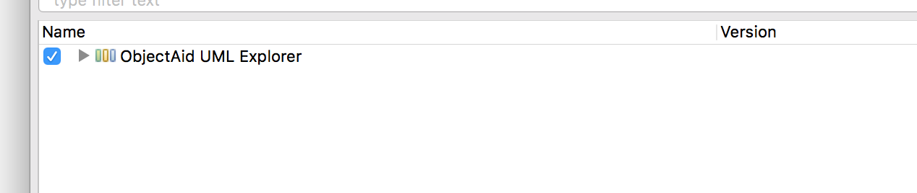

Choose Next > to start installation.

c. At the Install Details window, highlight (click on) where it says ObjectAid Diagram Add-On…

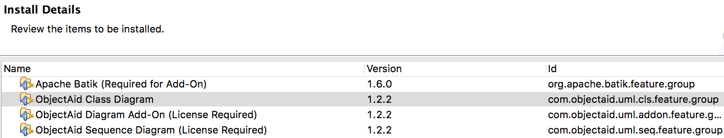

Press Next > to continue.

At the Renew Licenses window, choose where it says ObjectAid Diagram Add-On License

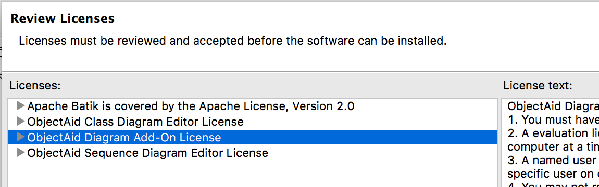

Accept the License agreement and click on Finish to complete your install.

Click Install anyway at the Security Warning pop up. Click Ok when prompted for a restart.

II. Creating a UML diagram for your project.

a. To create a UML diagram for your project once you have your packages/classes/interfaces setup, merely right click on your project name and select New > Other…

Scroll down to the ObjectAid UML Diagram and select **ObjectAid Class Diagram**.

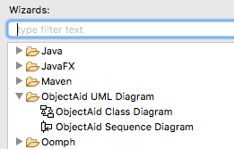

Click Next > to continue.

b. At the ‘Create a new UML Class Diagram’ window include a file Name for your UML diagram. Name your UML file as **yourInitials_UML_Phase1** (**ex. jp_UML_Phase1**).Include the default Folder for your file. Keep the default options and click Finish to create your **.ucls** file.

Snapshot follows…

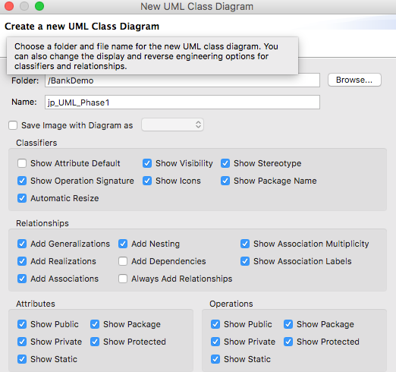

c. Create your diagram by highlighting all your java packages/project source files, click open your newly created **.ucls** file, then drag your files into your empty **.ucls** file area (labeled as your project name followed by the .ucls extension).

Snaphosts follow…

1. Highlight desired files…

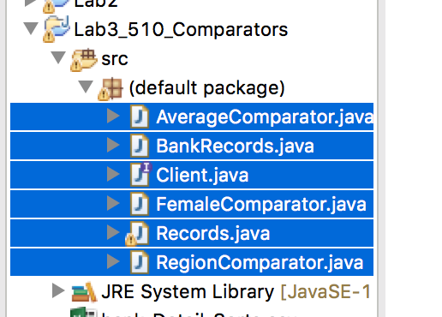

1. Click open your .ucls created file and drag files into open area of your .ucls file

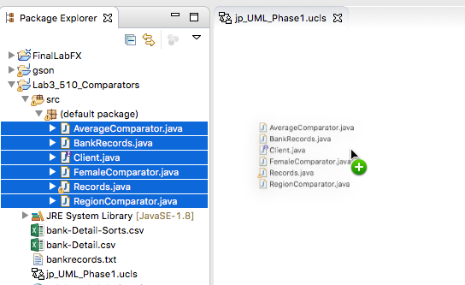

**Save your project at this point**.

III. Submitting your project (include all source files too!)

a. Right click on your project and choose Export. Under General choose Archive file.

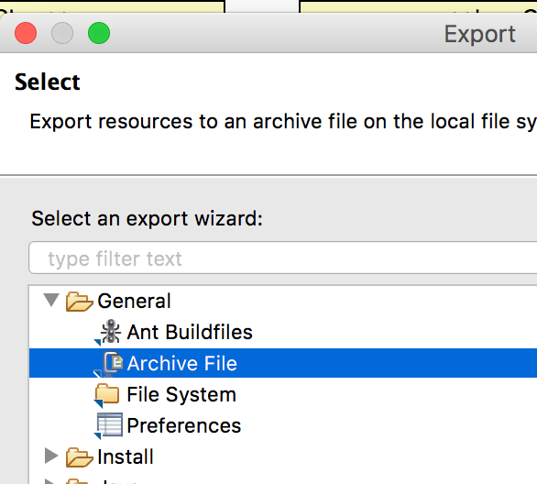

Click Next >.

b. Choose a destination for your export. Include your zip file name as follows:

**FinalProj_Phase1_yourName** where yourName is your **first initial** followed by the **first four letters** of your **last name**. Accept all defaults and click on Finish.

Example naming of zip file.

/Users/jamespapademas/Downloads/**FinalProj_Phase1_jpapa**.zip

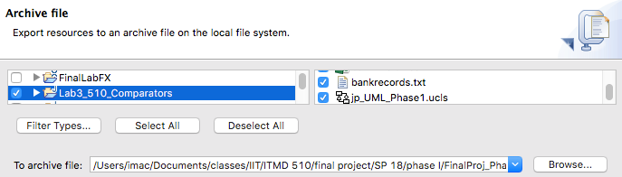

c. Submit your archive zip file to Blackboard for credit.

Some solid refs:

<https://creately.com/blog/diagrams/class-diagram-relationships/>

<https://circle.visual-paradigm.com/ticket-selling-system/>

Industry standard ( free for students!)

<https://www.microsoft.com/en-us/store/collections/visio/pc>

Mulitiplicity (Relationships)

<https://en.wikipedia.org/wiki/Class_diagram>